Captions for template files

**Note: Don’t change the header and sheet name of the files**

1. TC_test.xlsx

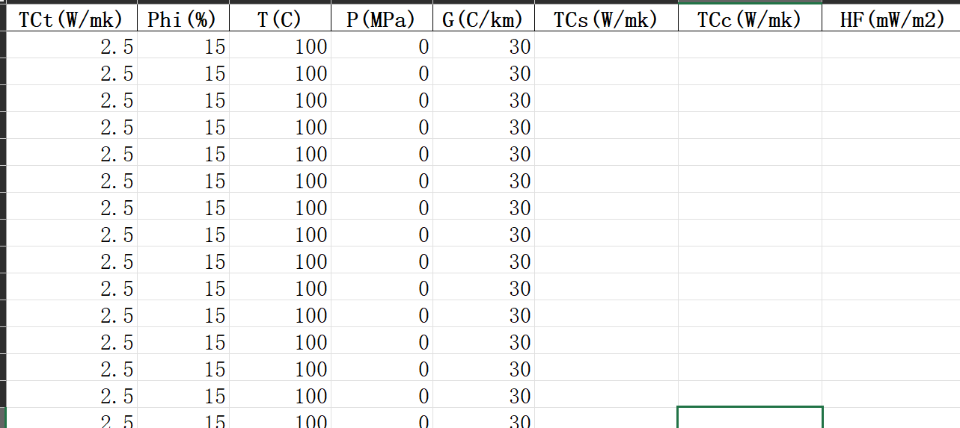

Input values:

TCt: tested thermal conductivity

Phi(%): porosity,

T: temperature,

P: pressure,

G: temperature gradient

Output values:

TCs: thermal conductivity of solid

TCc: corrected thermal conductivity

HF: terrestrial heat flow

1. Log_test.

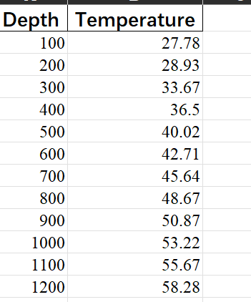

Input value : Depth in (m); temperature in (℃)

3）Temp_1D

3.1 Single profile

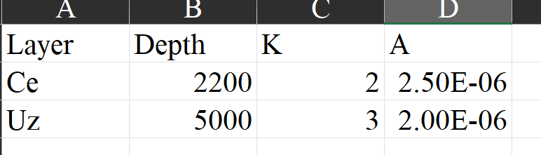

Layer: strata marker

Depth: bottom depth of the layer in m

K: thermal conductivity of the layer in W/mk

A: heat production of the layer in W/m3

3.2 Multiple profiles

q0: surface heat flow in W/m2

T0: surface temperature in ℃

The Layer, Depth, K, and A are same as single profile.

Sheet name is the name of the profile, which is set as the label of the temperature profile.

1. Temp_2D

There are three sheets in Temp_2D, Crust_structure, Thermal_para, and Bottom_boundary.

Crust_structure:

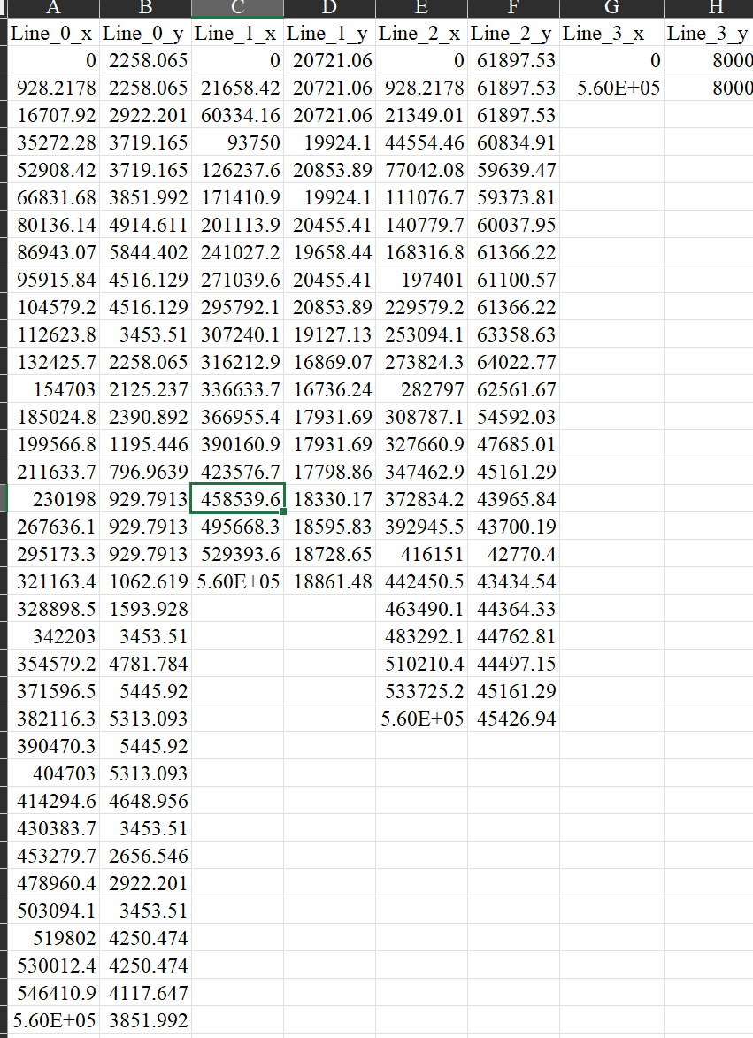

The geometric structure is described by several lines, x values (distance in m) in odd columns, y values (depth in m) in even columns . All layers should have same length in x direction. And the layers are arranged from top to bottom from left to right in the table. And the bottom downmost layer is the bottom boundary of the model, which must be a horizontal line. There are 4 layers in the template file, users can add new layer fellowing the rules, i.e. (Line_4_x, line_4_y).

Thermal_para:

Thermal parameters for the layers.

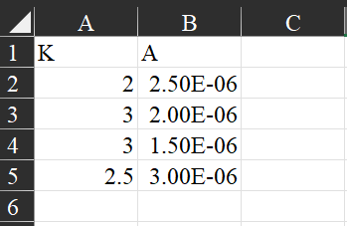

K is thermal conductivity in W/mk

A is heat production in W/m3

Bottom boundary:

Bottom boundary conditions

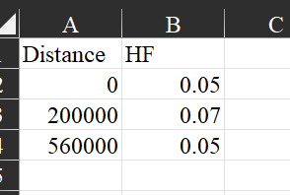

Distance in m, HF in W/m2

1. Tectono_thermo_test

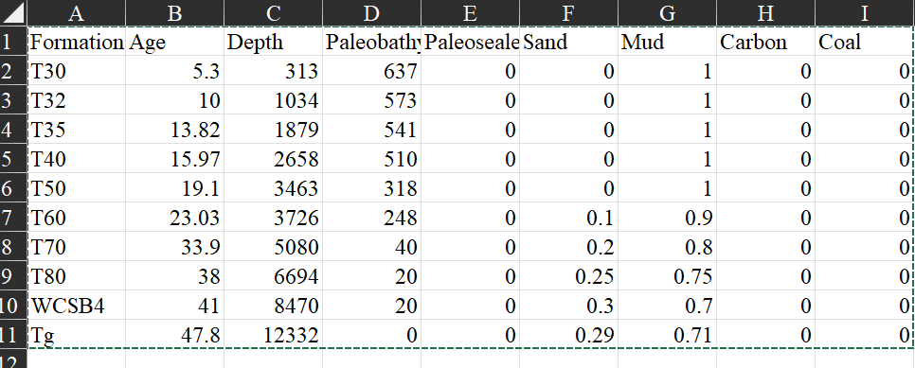

Formation: strata marker

Age: bottom age of the strata in Ma

Depth: bottom depth of the strata in m

Paleobathymeter: paleobathymeter for the top of the strata in m

Paleosealevel: paleosealevel for the top of the strata in m

Sand, Mud, Carbon, Coal : proportion of each composition.

It should be noted that the paleobathymeter and paleosealevel are the top age of the strata. For example, in T32 row, the bottom age of the strata is 10Ma, but the age of paleobathymeter and paleosealevel is the top of T32 (bottom of T30), 5.3Ma.